Bebop Babes
by BRIDGET CALLAHAN | photos by Erik Maasch

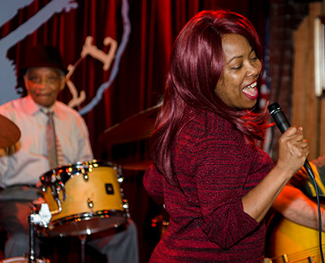
(left to right: Beverly J. sings at The Rusty Nail, Bria Skonberg headlines the NC Jazz festival, Benny Hill jams at The Rusty Nail)

